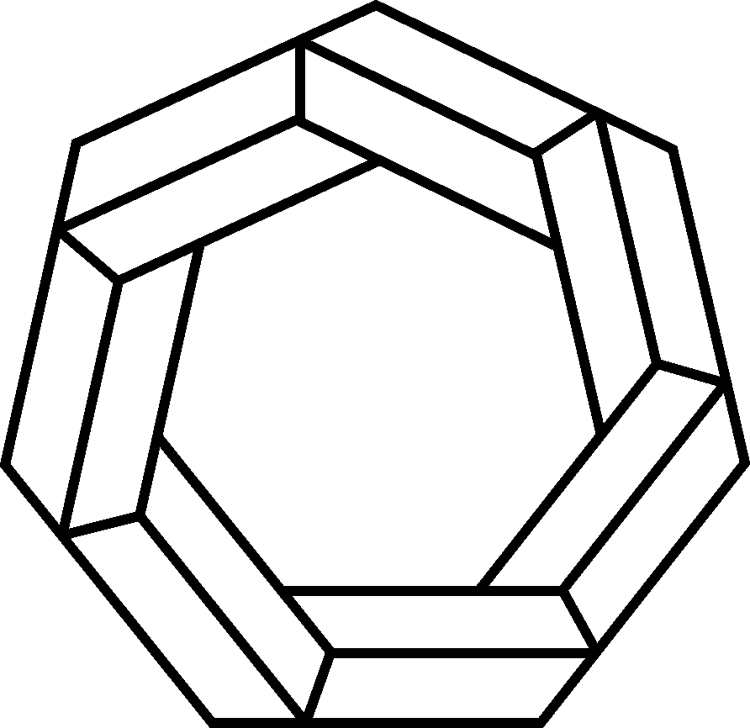
The 10th World Mathematics Team Championship
2019 Beijing. China
Organizers
China International Culture Exchange Centre(CICEC)
The World of Mathematics and Physics Journal
The Committee of Hope Cup Mathematics Competition
WMTC Committee

Purpose
- To strengthen the understanding and communication among youths from different regions and to help them foster friendships around the world.
- To cultivate the spirit of team work and cooperation among youths.
- To promote communication and cooperation among mathematicians and mathematics educators from around the globe and to help advance the development of mathematics education.
- To cultivate the youth’s interest in mathematics and improve their thinking abilities.

Date-Location-Schedule
Date: November 21- 25, 2019
Location: Beijing, China
Schedule:
November 21 – All Day: Registration
November 22 – 9:00 am – 11:00 am Team Leaders/Coaches/Proctors meeting
1:00 pm – 1:30 pm Opening Ceremony
1:50 pm – 2:30 pm Individual Round
2:40 pm – 3:10 pm Relay Round
3:40 pm – 4:20 pm Team Round
4:30 pm – 6:30 pm Grading
7:30 pm – 10:00 pm Lecture by Honored Guest and activities
November 23 – All Day Beijing Sightseeing
8:00 pm – 9:00 pm Organizing Committee Meeting
November 24 – All Day Beijing Sightseeing
7:00 pm – 9:00 pm Award Ceremony
November 25 – Depart for Home
* For teams that are coming from long distance away, they may arrive before November 21 or depart after November 25. We will assist in arranging for hotel rooms for them at their own expenses.

Group Divisions
Junior Level – For participants born after Sep 1, 2007 and study in primary school.
Intermediate Level – For participants born after Sep 1, 2004 and study in middle school.
Advanced Level – For participants born after Sep 1, 2001 and study in high school.
* Younger participants may participate in higher level.

Awards
Team Awards: In each division, the top 1/3 of the teams are ranked and get trophies and each of the team members gets a gold medal and a certificate. The other 2/3 teams get participation awards.
Individual Awards: In each division, the top 10% scoring individuals get gold medals, the next 20% scoring individuals get silver medals, the next 30% scoring individuals get bronze medals, and the next 40% scoring individuals get merit medals. Each individual gets a corresponding certificate. Individuals are also ranked by scores and each of the top three scoring individuals in each division gets a special trophy and a scholarship to honor his/her ranking.

Participants
(1) Team formation: A team can participate represent a country, a region, a city, or an educational institution such as a school. We will not accept registration for any person as an individual.
(2) Team members: Each team consists of 6 students and one team leader.

Scoring and Rules
Individual: 10 minutes each round for 3 rounds
Rounds 1 : 8 problems , 2 points per problem, total 16 points
Rounds 2 : 4 problems , 4 points per problem, total 16 points
Rounds 3 : 2 problems , 8points per problem, total 16 points
The average score of 6 members in a team will counted as a part of total score of team.
Relays: Each team divides into 3 groups with 2 persons in each group
8 minutes each round for 3 rounds
Each round has 2 problems as a set for each group to do relays
For each set, only the answer from the second member of the relays group will be counted. Total possible points for each group is 60
The average score of 3 groups in a team will counted as a part of total score of team.
Team: 40 minutes to solve 20 problems, 5 points per problem, total 100 points.
Discussion is allowed. Each team submits one answer sheet.
The score of the team round will counted as a part of total score of team.
 | Rounds | Problems | Time | Points of each problem | Total Score
Team | 1 | 20 | 40 Mins | 5 points | 100
Relays | 3 | 6 | 24 Mins | 20 points | 60
Individual | 3 | 14 | 30 Mins | 2 points/4 points/8 points | 48

Language: Chinese & English
Electronic devices such as calculator or computer (including microcomputer) will not be allowed during any of the above rounds.

Fees
- Registration fee is US$75 per team member or alternate.
- Expense cost is US$560 per team member. This fee pays for each team member’s meals for 5 days, 4 nights of hotel rooms, transportation (including airport pick up and drop off), sightseeing tours, certificates, medals, trophies, souvenirs, etc. This fee will be charged when the team members arrive in Beijing for registration.
- For every full team with 6 participants, one team leader will not be charged for the expense cost. Another alternate full team registration fee will be charged.
Registration
- Download the registration from WMTC official website: www.wmtc-math.net . Send the completed registration form through e-mail to office@wmtc-math.net.
- Registration ends at: October 15, 2019

